**ASSIGNMENT 1 FRONT SHEET**

|  |  |  |  |
| --- | --- | --- | --- |
| **Qualification** | **BTEC Level 5 HND Diploma in Computing** | | |
| **Unit number and title** | Unit 06: Managing a Successful Computing Project | | |
| **Submission date** | 04/04/2021 | **Date Received 1st submission** |  |
| **Re-submission Date** | 11/05/2021 | **Date Received 2nd submission** |  |
| **Student Name** | PHAM CAO NGUYEN | **Student ID** | GCC18074 |
| **Class** | GCC0801 | **Assessor name** | NGUYEN TRUNG VIET |
| **Student declaration**  I certify that the assignment submission is entirely my own work and I fully understand the consequences of plagiarism. I understand that making a false declaration is a form of malpractice. | | | |
|  |  | **Student’s signature** | CAONGUYEN |

**Grading grid**

|  |  |  |  |  |  |  |
| --- | --- | --- | --- | --- | --- | --- |
| P1 | P2 | P3 | P4 | M1 | M2 | D1 |
|  |  |  |  |  |  |  |

|  |  |  |
| --- | --- | --- |
| **❒ Summative Feedback: ❒ Resubmission Feedback:** | | |
| **Grade:** | **Assessor Signature:** | **Date:** |
| **IV Signature:** | | |

**ASSIGNMENT 1 BRIEF**

|  |  |  |  |
| --- | --- | --- | --- |
| **Qualification** | **BTEC Level 5 HND Diploma in Computing** | | |
| **Unit number and title** | Unit 06: Managing a Successful Project | | |
| **Assignment title** | Plan and conduct a small scale research activity | | |
| **Academic Year** | 2020 - 2021 | | |
| **Unit Tutor** | HOANG Nhu Vinh | | |
| **Issue date** | 29 Sep 2020 | **Submission date** | 29 Sep 2020 |

|  |
| --- |
| **Submission Format:** |
| *Format:* The submission is in the form of an individual written report that shows how you have manage the project. This should be written in a concise, formal business style using single spacing and font size 12. You are required to make use of headings, paragraphs and subsections as appropriate, and all work must be supported with research and referenced using the Harvard referencing system. Please also provide a bibliography using the Harvard referencing system.  *Submission* Students are compulsory to submit the assignment in due date and in a way requested by the Tutors. The form of submission will be a soft copy in PDF posted on corresponding course of <http://cms.greenwich.edu.vn/>  *Note:* The Assignment *must* be your own work, and not copied by or from another student or from  books etc. If you use ideas, quotes or data (such as diagrams) from books, journals or other sources, you must reference your sources, using the Harvard style. Make sure that you know how to reference properly, and that understand the guidelines on plagiarism. *If you do not, you definitely get fail* |
| **Assignment Brief and Guidance:** |
| **Introduction to theme Internet of Things** The Internet of Things (IoT) is the term which refers to the ever-growing network of physical objects with embedded sensors which can connect together via the internet allowing communication to occur between these objects and many other Internet-enabled devices and systems.  The IoT is quickly becoming a necessary aspect of people’s daily lives. Physical items can now sense and collect data which can be controlled through digital and smart technology. The IoT extends internet connectivity beyond traditional devices like desktop and laptop computers, smartphones and tablets to a diverse range of devices that can utilise embedded technology such as security systems, thermostats, cars, electronic appliances, lights, medical equipment etc. These devices, often called "connected" or "smart" devices, can talk to other related devices (machine-to-machine (M2M) communication) and act on the information they get from one another.  Along with the many benefits there is also considerable concern over the IoT which must be overcome in order to harness the power of this free flow of information. This unit will enable students to explore the benefits of the IoT, the potential future developments, the most pressing challenges and how to overcome them.  Tasks  As a member of Research and Development department, you have been assigned a mini-project to find out do digital technologies improve life or distract from it and to explore the efficacy of products and features specifically designed to improve health and wellbeing.  You need to do primary research (both qualitative and quantitative research) and secondary research to find out that impact and conduct a report for your research. Even it’s a mini-project, you must apply project management (PM) techniques such as project charter with aims, objectives, cost etc. As for time management, you need to produce WBS and Gantt chart with reasonable tasks and time. A project logbook is required to provide evidence of the project development process and ongoing reflection for every week. This logbook will be needed later for your reflection and evaluation in Assignment 2. As part of QA (quality assurance) policy, in the report you also need to critically evaluate the PM process and appropriate research methodologies applied.  Your report must have an introduction stating the project aims and objectives. This must be followed by a copy of your project management plan. Your plan should show the milestones when you will review with your tutor your ongoing progress so far. You will submit your logbook which shows how you have carried out the project.  Guidance for Students  You should read this information before starting on your project. You should refer to these instructions as you complete work for this unit.  • Read the brief and think about what the project brief is asking.  • Research what the project brief is asking. How can you approach the problem, opportunity, hypothesis and requirements being posed?  • Apply a range of secondary research sources to plan/scope and support the project and its findings. Secondary research sources may include textbooks, journal articles, newspapers and magazine articles (not factual accounts).  • Develop your project plan based on the deliverables of the project, the constraints of the project and the assumptions made.  • Conduct your project according to your stated project plan and meet with your tutor to receive a sign-off at each stage of the project process.  • Primary research sources may include original first-hand accounts, legal and historical documents, results of experiments and market research data collection. Apply both qualitative and quantitative research methods to evaluate data collected from primary research.  • Keep notes of your progress throughout the project in your logbook. This is an important record of your work and must be used to record the development of your ideas and your progress through the project. The logbook should include:  • A record of what you did, when and what you were thinking.  • A record of where things went wrong and what you did to overcome any unexpected results.  • You will be asked to reflect on the success of your project and your own performance in a personal performance review at the end of the project. This is a written reflection of around 500 words.  • You must complete the project in order to complete your work for this unit.  Resources and useful links   |  |  |  | | --- | --- | --- | | **Type of Resource** | **Resource Titles** | **Links** | | Web blog | What risks do IoT security issues pose to businesses? | https://blog.avast.com/iot security-business risk#:~:text=The%20biggest %20IoT%20threats%20to%20 businesses&text=One%20of %20the%20main%20IoT,if%2 0hacked%20by%20a%20cyb ercriminal. | | Website | 9 Main Security Challenges for the Future of the Internet Of Things (IoT) | https://readwrite.com/2019/ 09/05/9-main-security challenges-for-the-future-of the-internet-of-things-iot/ | | Website | The world’s best smart cities don’t just adopt new technology: they make it work for people | https://www.citymetric.com/ horizons/world-s-best-smart cities-don-t-just-adopt-new technology-they-make-it work-people-4815 | | Website | Spotlight on the Internet of Things | https://www.ericsson.com/e n/future technologies/future-iot | | Website | Ericsson Technology Review: Spotlight on the Internet of Things - | https://www.ericsson.com/e n/reports-and papers/ericsson-technology review/articles/spotlight-on the-internet-of-things | | Online Magazine | Erricsson Technology Review: Spotlight on the Internet of Things | https://www.ericsson.com/4 a9407/assets/local/reports papers/ericsson-technology review/docs/2019/etr magazine-2019-special issue-iot.pdf | | YouTube Video | IoT and Machine Learning - Changing the Future | Dr. Dennis Ong | TEDxOhioStateUniversity | https://www.youtube.com/w atch?v=mlE03Fj2T9s | | YouTube Video | The coming privacy crisis on the Internet of Things | Alasdair Allan | TEDxExeterSalon | https://www.youtube.com/w atch?v=yG4JL0ZRmi4 | | YouTube Video | Internet of Things: Are Smart Devices Helping or Harming? | Rose Barker | TEDxSalem | https://www.youtube.com/w atch?v=ipdTLJcIkWI | |

|  |  |  |
| --- | --- | --- |
| **Learning Outcomes and Assessment Criteria** | | |
| **Pass** | **Merit** | **Distinction** |
| **LO1** Establish project aims, objectives and timeframes based on the chosen theme | | **LO1 & LO2**  **D1.** Critically evaluate the  project management  process and appropriate  research methodologies  applied. |
| **P1** Devise project aims and objectives for a chosen scenario.  **P2** Produce a project management plan that covers aspects of cost, scope, time, quality, communication, risk and resources.  **P3** Produce a work breakdown structure and a Gantt Chart to provide timeframes and stages for completion. | **M1** Produce a comprehensive project management plan, milestone schedule and project schedule for monitoring and completing the aims and objectives of the project. |
| **LO2** Conduct small-scale research, information gathering and data collection to generate knowledge to support the project | |
| **P4** Carry out small-scale research by applying qualitative and quantitative research methods appropriate for meeting project aims and objectives | **M2** Evaluate the accuracy and reliability of different research methods applied. |

Contents

Devise project aims and objectives for a chosen scenario. (P1) 9

**1.** **Project management introduction.** 9

2. Definition of project management. [1] 9

3. Definition of software project management. [2] 9

4. The key stages of project management. [3] 9

**5.** **The advantage of project management. [6]** 11

6. Main aim of the project 11

7. List of Objectives to achieve 11

Produce a project management plan that covers aspects of cost, scope, time, quality, communication, risk and resources. (P2) 12

Produce a work breakdown structure and a Gantt Chart to provide timeframes and stages for completion. (P3) 14

1. WBS. 14

2. Gantt Chart 15

Carry out small-scale research by applying qualitative and quantitative research methods appropriate for meeting project aims and objectives. (P4) 18

1. What is qualitative research? [4] 18

4. What is quantitative research? [5] 19

5. Implementation stage: 19

6. Efficiency of quantitative research methods and qualitative research methods: 20

References 21

# Devise project aims and objectives for a chosen scenario. (P1)

1. **Project management introduction.**

* Equipment creation Farm Temperature and Humidity Sensor based on IOT automation project. It has been established that SMART agricultural technology helps to monitor farming. The aim has been to initiate better crop production thus innovating the landscape of existing farming methods. Organic farming has been recently based on the internet of things as it helps to provide information related to crop yields and developing the Device organic Farm Temperature and Humidity Sensor as well as the content of moisture in the soil. The methods are mostly sensor-based that are known to compute humidity and temperature and as well as plant growth. IOT can help more in measuring temperature and humidity sensors with the help of sensors to analyze and report changes in the air inside the farm. It can be concluded that the IoT in addition to temperature and humidity sensors can also reflect the total growth of plants as well as the air and moisture content required for their growth. It makes it easier for users to be more convenient without spending a lot of time, cost, and manpower when it can be easily viewed and the device can adjust to the creature inside the farm perfectly.

## Definition of project management. [1]

* Project management is the method of directing the team's work towards achieving the targets and meeting the requirements for performance at a specified time. The primary task of project management is to meet all the aims of the project within the limits set. This knowledge is generally outlined in the project documents generated at the beginning of the development process. Scope, time, quality, and budget are the primary constraints. The secondary task is to maximize the allocation of the required inputs and to apply them to the achievement of pre-defined objectives. (Kerzner,2017)

## Definition of software project management. [2]

* A Software Project is the complete procedure of software development from requirement gathering to testing and maintenance, carried out according to the execution methodologies, in a specified period of time to achieve the intended software product. (Wysocki, 2010)

## The key stages of project management. [3]

* **Project Initiation:** The first step of project management entails giving the project a general meaning and determining whether or not it is feasible. The stakeholders in charge will normally use one of two approaches to determine whether or not to approve the project:
* **Business Case Document:** This will outline the project’s rationale in terms of what the customer requires, how it will support them, and whether or not it will generate a financial return.
* **Feasibility Study:** This paper analyses the resources needed to complete the project and compares them to the organization’s resources. In this way, the project’s timeline and cost are assessed, as well as if the corporation is the best fit.
* If the project passes these two exams, the next stage in the initiation process is to create a project charter or project initiation paper, which will include an outline of the project's goals, partners, and business scenario.
* **Project Planning:**
* Selection of the topic for the project. Create the layout, map which will be helpful in the future project, analysis of the design for planning purpose. Create the plan, Gathering data. Planning for further process to achieve the milestone. The development of the model and checking the impact of technologies.
* **Project planning includes:**
* Defining the scope of the project
* Identifying what exactly needs to be done
* Finalizing the timeline for deliverables
* Organizing a workflow schedule
* Assessing and arranging necessary resources
* **Project Execution:**
* This is the start of the artistic cycle, in which the meticulously planned project plans are transformed into concrete deliverables. A kick-off meeting is normally held to provide everyone with an outline of their goals.
* **Project Research:**
* Research & Development on the project literature review, creating the Gantt Chart and WBS plan and integration of Annotated Bibliography.
* **Project execution includes:**
* Create individual task sequences
* Procurement of necessary resources
* Assign detailed tasks to each person
* Perform mission
* Deliver products delivered within the term
* Update project progress
* **Project Monitoring:**
* The project manager serves as a vital link between the project management and other stakeholders who are less involved in the day-to-day aspects of the project. As a result, a project manager must be able to accurately measure and communicate project success in order to ensure that it is running smoothly.
* **Project Closure:**
* The final deliverables are turned over or go live at this point of project management. This stage allows you, your colleagues, and your partners to assess how good the project was and what lessons were learned along the way. It is also wise to create an ongoing process to capture this knowledge and formally and feed it back into your project management system
* Creating a draft of the seminar presentation, entry of weekly blog posts to be noted, the final delivery or report of the project.

1. **The advantage of project management. [6]**

* The first and most important benefit is that each project is managed by a different project manager who can focus only on the project, increasing the chances of completion.
* Another advantage of project management is that it aids the organization in ensuring productivity in terms of finance, manpower, and other operating costs by keeping a close eye on all project operations, which in turn aids management in finding revenue-leaking areas and allowing the company to save a significant amount of money.
* It assists the organization in cultivating leadership qualities in talented individuals by assigning them small jobs first, then large projects, which creates a positive environment in the company where employees feel there is plenty of room for progress.
* Project management establishes a framework for measuring and accounting for workflow, ensuring that resources are used wisely to achieve the project's objectives. This method of preparation sets specific goals for employees, offers clear guidelines, and includes protocols for dealing with unpredictable outcomes quickly.
* Managing tasks from beginning to end will help a project manager keep track of his budget and find challenges or concerns before they become roadblocks. This will also assist a company in ensuring on-time output, retaining loyal clients, and projecting a professional picture.
* In the early stages of project preparation, effective project managers make decisions on sufficient hiring and team development. This will help ensure that the project's responsibilities are delegated to the right employees with the right skill sets, helping the organization to use its human capital wisely and efficiently. (Kerzner, 2002)

## Main aim of the project

* Device organic Farm Temperature and Humidity Sensor based on IOT automation project.

## List of Objectives to achieve

* Problems that the project needs to solve: This project points out the benefits of this device for user convenience. The project will track temperature and humidity measurements and adjust to the organisms inside the farm.
* Can sense the temperature and humidity of the air.
* Can automatically filter the air
* Can even adjust the temperature to suit the organism inside.
* Automatically adjusts humidity.
* We can control the internal temperature by voice
* The system can connect to all software and applications, even on smartphones
* The system is always updated with the temperature and humidity will be displayed on all devices
* Time: for a time objective, we will testing the error so that we could implement the app on time and finish the deadline in three months according to the plan.
* Realistic: for a realistic objective we will conduct a survey and interview the customer and get reviews from them to help develop the app suit with customer’s need
* Achievable: for an achievable objective, we will do step by step and collection and analysis of customer requirements
* Measurable: We can know the change by periodically monitoring the app per week and run testing per month to see if the function has been achieved or not yet.
* Specific: This project is planned and implemented by 4 people and the aim of this project is to planning and develop an organic Farm Temperature and Humidity Sensor based on the IoT automation project. (Schwalbe, 2009)

# Produce a project management plan that covers aspects of cost, scope, time, quality, communication, risk and resources. (P2)

* Establish your aims and objectives for the project. Outline objectives and timeframes based on the scenario.
* Produce an appropriate project management plan that includes relevant actions to meet objectives and timeframes
* Analyze your findings and draw conclusions to form the basis for recommendations.
* Write recommendations based on the research findings and outcomes.
* Write report writing focusing on personal development and project journey in a critical and objective way

1. **Scope:** We are going to create an Organic Farm Temperature and Humidity Sensor based on an IOT automation project. Can connect to all devices and run on any platform.
2. **Time:** The project will finish in 3 months.
3. **Communication:**

* Stakeholders must be notified of a specific and detailed update during project implementation.
* The method of updating project information will use internal mail to avoid disclosing information to unrelated parties.
* Meeting, messaging…

1. **Risks:**

|  |  |  |  |  |  |
| --- | --- | --- | --- | --- | --- |
| **Risk** | **Assess the Risk (Low, Medium, High)** | **Effect on the Project** | **Responsible** | **Settlement Plan** | **Revised evaluation** |
| Employee productivity | Medium | The project’s progress would be significantly hampered if staff were inefficient. | Leader | Plan implementers must be qualified to have a thorough understanding of the project's problems. They must be capable of handling their project’s work. | Low |
| Deviation from the existing project plan | High | It will not pursue the project’s planned course and will not reach its intended target. | Leader | Before starting a project, it's important to carefully and simply review the development strategy. Reduce the impact to the smallest amount possible. Assisting with the project’s smooth start. | Low |
| The project has not been finished on time | High | Perhaps the cancelation of the project may be very high. | Leader | It is prudent to include a timetable for a realistic project, reassess the project implementer’s results, and establish an appropriate timetable to avoid project delays or cancellations. | Low |
| The supplier cannot meet the requirements | Medium | Failure to meet a supplier’s obligations will trigger a delay in the project’s execution. Concerns on product consistency are also addressed. | Leader | Examine and check the provider that wants to work with you carefully. Aside from imposing certain restrictions on the materials that the supplier supplies for the project during the implementation phase. | Low |

**Table 1: Risk board**

1. **Resources:**

* The equipment requirements for the project should include hardware and software. Besides, human resources are indispensable.

1. **Cost estimation:**

|  |  |  |  |  |
| --- | --- | --- | --- | --- |
| **Stt** | **Line Item/labor** | **Cost** | **Working time** | **Total** |
| 1. | Leader (Nguyen) | $ 5/h | 8h/day | $ 2.624 |
| 2. | Members (Tu, Viet, Dat) | $ 3/h | 8h/day |
| 3. | Printer | $ 5/h |  |
| 4. | Photocopier | $ 5/h |  |
| 5. | Develop Project Charter | $ 500 |  | $ 2.000 |
| 6. | Build and buy some other equipment | $ 500 |  |
| 7. | Test | $ 200 |  |
| 8. | System deployment | $ 800 |  |
| **Total** | | | | **$ 4.624** |

**Table 2: predict the cost**

# Produce a work breakdown structure and a Gantt Chart to provide timeframes and stages for completion. (P3)

## WBS.

* **What?**
* WBS stands for Work Breakdown Structure, roughly translated as Work Breakdown Structure. WBS is a hierarchical decomposition of the entire scope of work that will be done by the project team to accomplish the project's goals and create the required deliverables. WBS organizes and determines the total scope of the project and represents the work specified in the currently approved project scope statement.
* WBS is a deliverable-oriented hierarchical decomposition of the work to be executed by the project team to accomplish the project objectives and create the required deliverables.
* **Why?**
* Risks are identified by the work package:Therefore, during risk planning, risks that are associated with each item in the WBS Project Management are outlined and all project risks are identified with the help of WBS.
* Accurately subdivide the project into smaller work packages. This has dual benefits of making tasks easier for project members to manage and allowing key milestones to be identified.
* The WBS is an essential tool to define the project scope. It clearly defines what is included, and what is not included, in your project scope and deliverables. Establishing this early on is very helpful in client interactions. It prevents a lot of misunderstandings and results in much happier clients.
* An effective WBS means project tasks can be delegated and managed. Because the work is properly defined, it can be scheduled, costed, implemented, monitored and controlled. This allows you to measure progress and ensures that your projects will be delivered on time, on budget and on scope.
* A well-defined WBS reduces the risk of projects failing to meet goals and objectives. Because it identifies all tasks required to complete the project, the WBS reduces the potential for conflict on what is and is not included in the project, reduces the likelihood that key work will be omitted, and allows forward planning to ensure adequate resources will be on hand to complete project tasks.

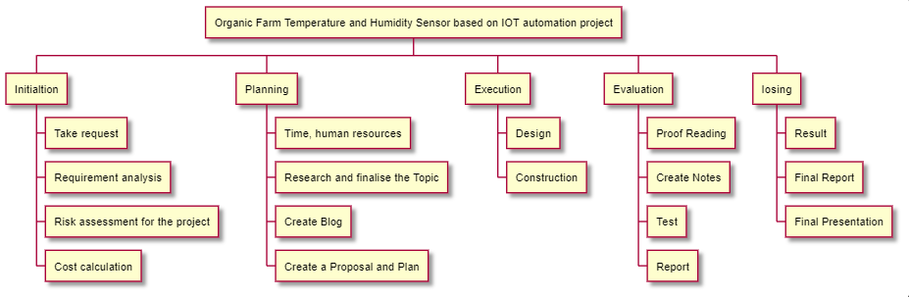

**Figure 1. WBS for project**

## Gantt Chart

* **What?**
* A Gantt chart is a project management tool assisting in the planning and scheduling of projects of all sizes, although they are particularly useful for simplifying complex projects. Project management timelines and tasks are converted into a horizontal bar chart, showing start and end dates, as well as dependencies, scheduling and deadlines, including how much of the task is completed per stage and who is the task owner. This is useful to keep tasks on track when there is a large team and multiple stakeholders when the scope changes.
* Project management solutions that integrate Gantt charts give managers visibility into team workloads, as well as current and future availability, which allows for more accurate scheduling.
* **Why?**
* Gantt charts are useful for planning and scheduling projects. They help you assess how long a project should take, determine the resources needed, and plan the order in which you'll complete tasks. They're also helpful for managing the dependencies between tasks.
* A Gantt chart displays tasks compared to time, with tasks represented by horizontal bars. The length of each bar represents the amount of time that task has been allotted.
* What tasks are coming next
* How long each task will take
* When tasks need to be started and completed
* Any overlap between tasks
* Task dependencies
* Who is assigned to each task
* Milestones typically appear on a Gantt chart as diamonds or stars, and each represents a single point in time with no duration.

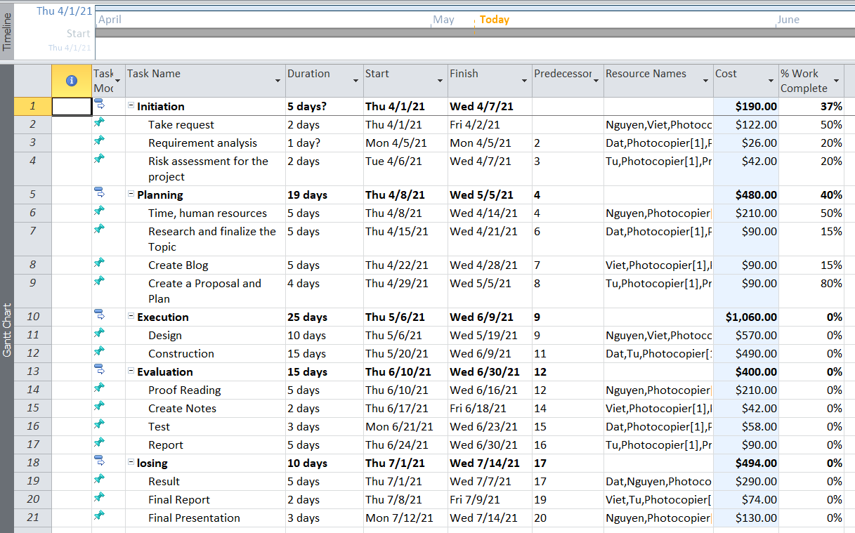

**Figure 2. Gantt chart**

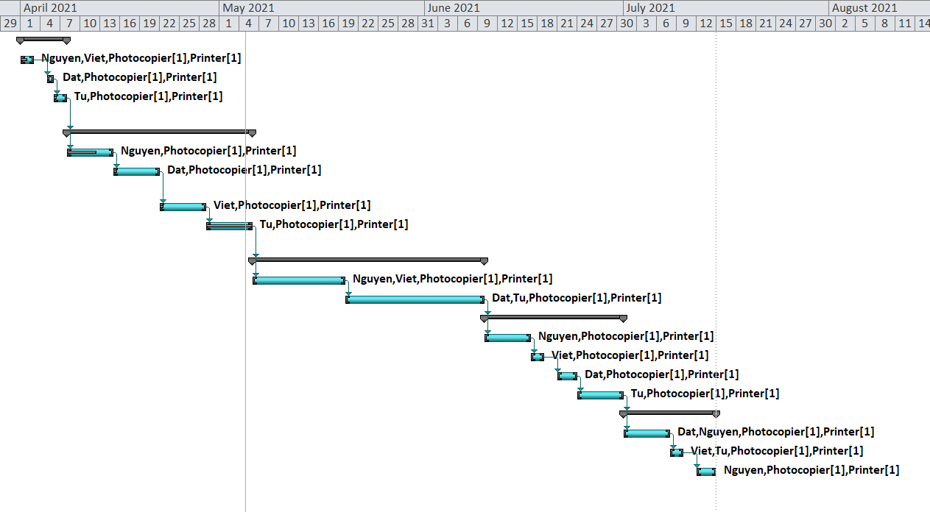

**Figure 3. Gantt chart**

* You can brainstorm your initial schedule: A Gantt chart can be an effective way to create your initial project schedule and workflow. The largest advantage of using a Gantt chart as the starting point for planning your project is that it’s visual. You can display it on a large screen in a conference room and walk through it with your team much more easily than a list or table of tasks.
* You can break projects down: A Gantt chart can help you break a project into phases or sprints while still maintaining an overview of the project as a whole.
* Real-time updates: One significant advantage of using project management software is that it enables you to view changes and updates to your Gantt chart in real-time.

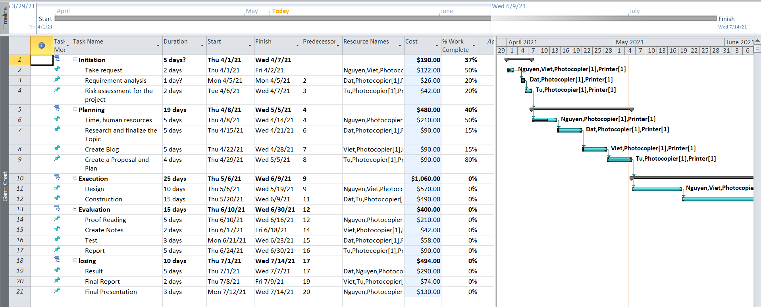

**Figure 4. Gantt chart overview**

# Carry out small-scale research by applying qualitative and quantitative research methods appropriate for meeting project aims and objectives. (P4)

## What is qualitative research? [4]

* The qualitative analysis relies on unstructured and non-numeric data. The data shall include field notes written by the researcher during the course of his or her observation, interviews and questionnaires, focus groups, participant observation, audio or video recordings made by the researcher in natural settings, documentation of various kinds (publicly accessible or confidential, paper or electronic records already accessible or generated by the researcher).
* Qualitative research method is a form of research often used to explore, find out ideas and views to find insight into problems. In addition, this method can be used to detect future customer trends.
* The modes of data collection for qualitative research are quite varied and often do not have a specific structure like quantitative research. Some of the methods can be mentioned such as focus group, personal interview, and observation. Samples of this method are usually small and are more carefully selected.
* Qualitative research usually approaches research subjects in the most natural way, to ensure that the behaviors, opinions, and opinions given by research subjects will be most objective and accurate.
* **Question:**
* Is this project really more convenient than manual temperature measurement?
* Does this device give you satisfaction?
* Is the price of the equipment appropriate?
* Does equipment installation help increase farm productivity?
* Would you recommend our product to your friends?
* What are the disadvantages when are you using this sensor device?

1. **Approaches to qualitative research:**

* Qualitative research is used to understand how people experience the world. While there are many approaches to qualitative research, they tend to be flexible and focus on retaining rich meaning when interpreting data.
* Common approaches include grounded theory, ethnography, action research, phenomenological research, and narrative research. They share some similarities but emphasize different aims and perspectives.

1. **Qualitative research methods:**

* Observations: recording what you have seen, heard, or encountered in detailed field notes.
* Interviews: personally asking people questions in one-on-one conversations.
* Focus groups: asking questions and generating discussion among a group of people.
* Surveys: distributing questionnaires with open-ended questions.
* Secondary research: collecting existing data in the form of texts, images, audio or video recordings, etc. (Silverman, 2020)

## What is quantitative research? [5]

* The quantitative research method is the collection and analysis of information on the basis of data collected from the market. The purpose of quantitative research is to draw market conclusions through the use of statistical methods to process data and data.
* Quantitative analysis is a systematic empiric study of measurable phenomena using statistical, mathematical, or computational techniques. Quantitative research aims to establish and use mathematical models, theories, and hypotheses on phenomena.
* Quantitative research is the process of collecting and analyzing numerical data. It can be used to find patterns and averages, make predictions, test causal relationships, and generalize results to wider populations.
* Quantitative research is the opposite of qualitative research, which involves collecting and analyzing non-numerical data. (Hoy, Adams,2015)
* **Question:**
* The level of customer satisfaction with the device
* The safety of the system
* Do you satisfied with the device our temperature humidity sensor?
* Temperature sensor speed, humidity quickly
* Equipment accuracy

## Implementation stage:

* The implementation phase involves implementing details of your project charter to deliver your products or services to your customers or internal stakeholders.
* The methods of locating, executing, and supplying the product to the customer are typically the three key components of project implementation.

## Efficiency of quantitative research methods and qualitative research methods:

* Quantitative research method: Quantitative research allows one to gather data through product enhancement assessments, as well as for expense statistics and forecasting, and for investing money wisely.

# References

[1] Kerzner, H., 2017. *Project management: a systems approach to planning, scheduling, and controlling*. John Wiley & Sons.

[2] Wysocki, R.K., 2010. *Effective software project management*. John Wiley & Sons.

[3] Schwalbe, K., 2009. *Introduction to project management*. Boston: Course Technology Cengage Learning.

[4] Silverman, D. ed., 2020. *Qualitative research*. Sage Publications Limited.

[5] Hoy, W.K. and Adams, C.M., 2015. *Quantitative research in education: A primer*. Sage Publications.

[6] Kerzner, H., 2002. *Strategic planning for project management using a project management maturity model*. John Wiley & Sons.